PROGRAMS USING RAPTOR:

1. Finding whether the given integer is odd or even?

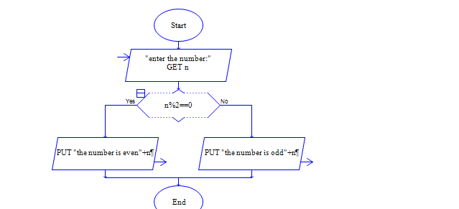

1. Finding the given integer is positive or negative?

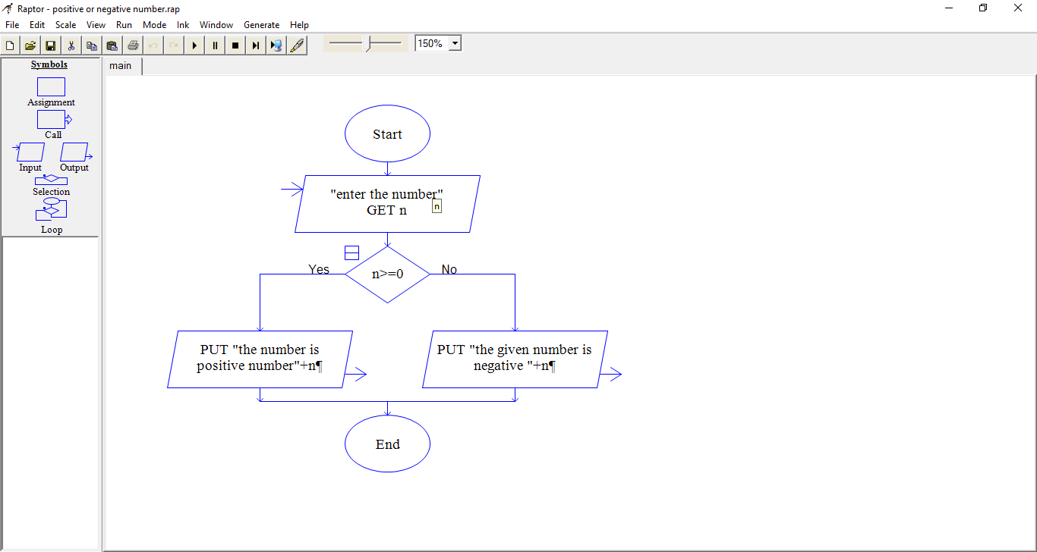

1. Generation of Fibonacci series 0,1,1,2,3,5,8……n ?

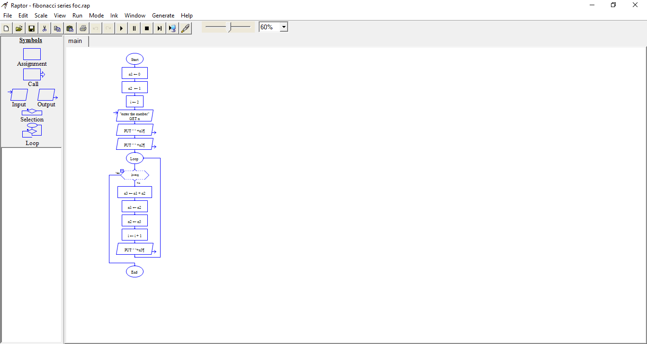

1. 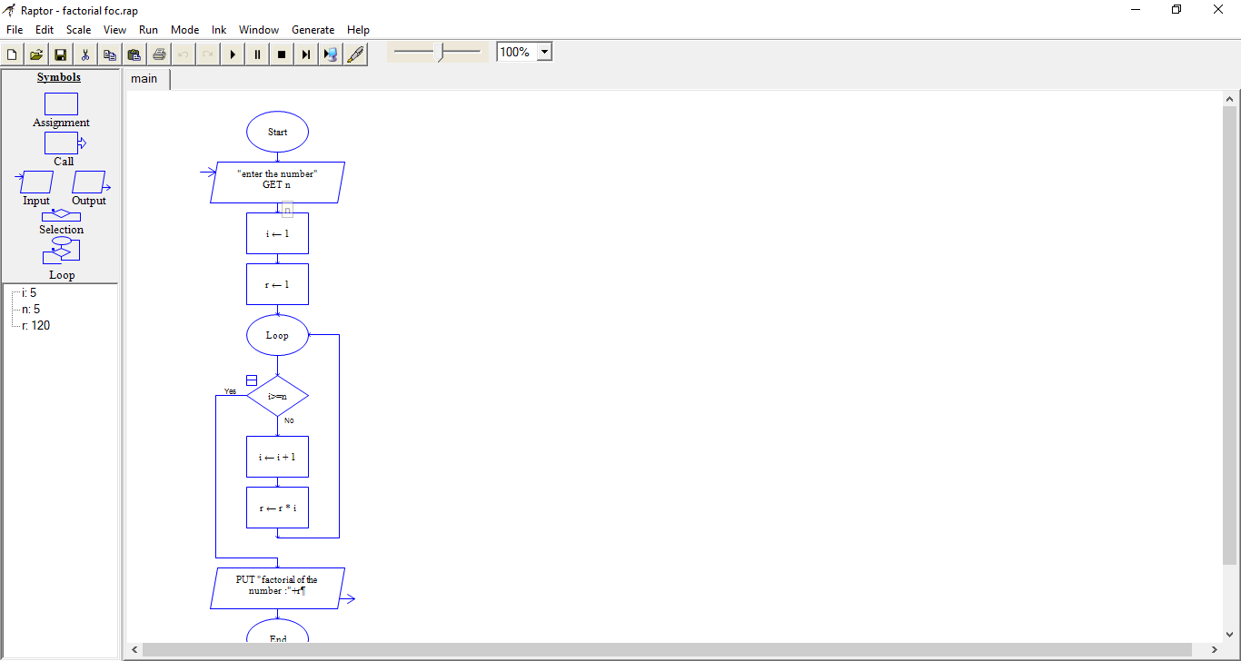Program for finding the factorial of a given number (product series) ?

1. Finding the given number is Armstrong or not?

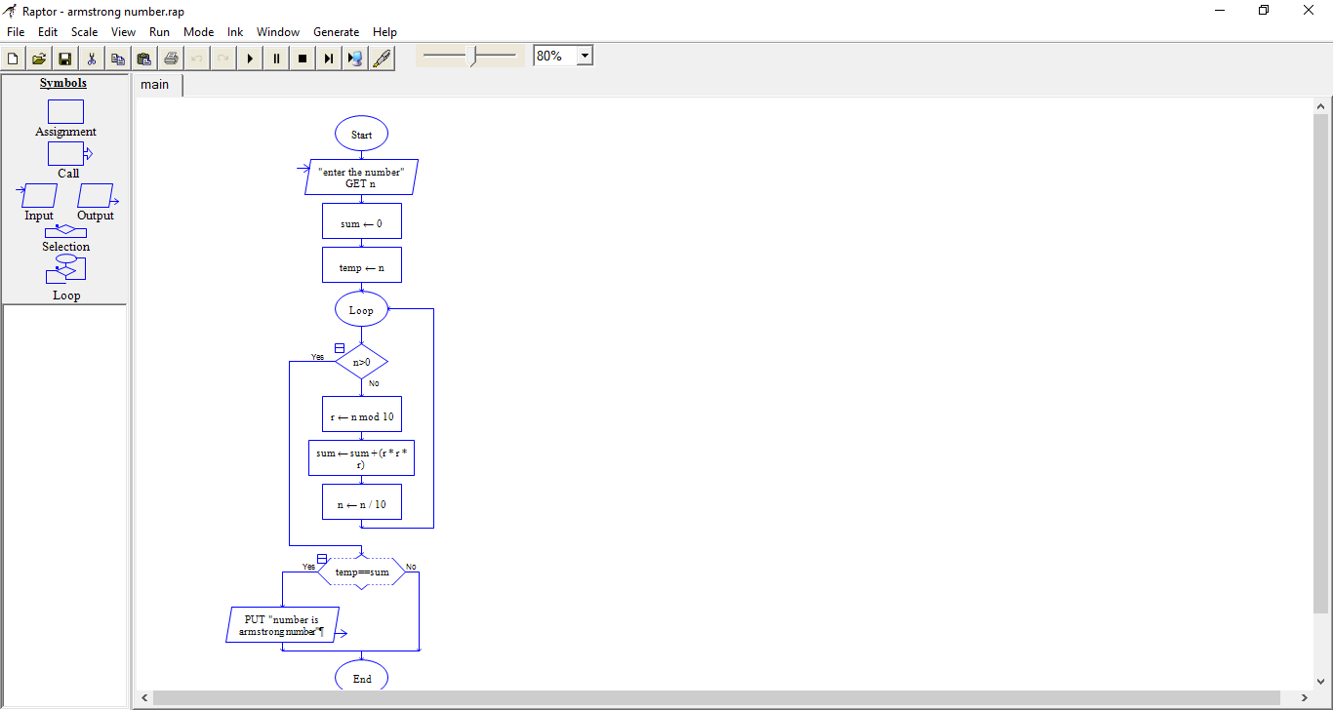

1. Summing up the n numbers and finding its average ?

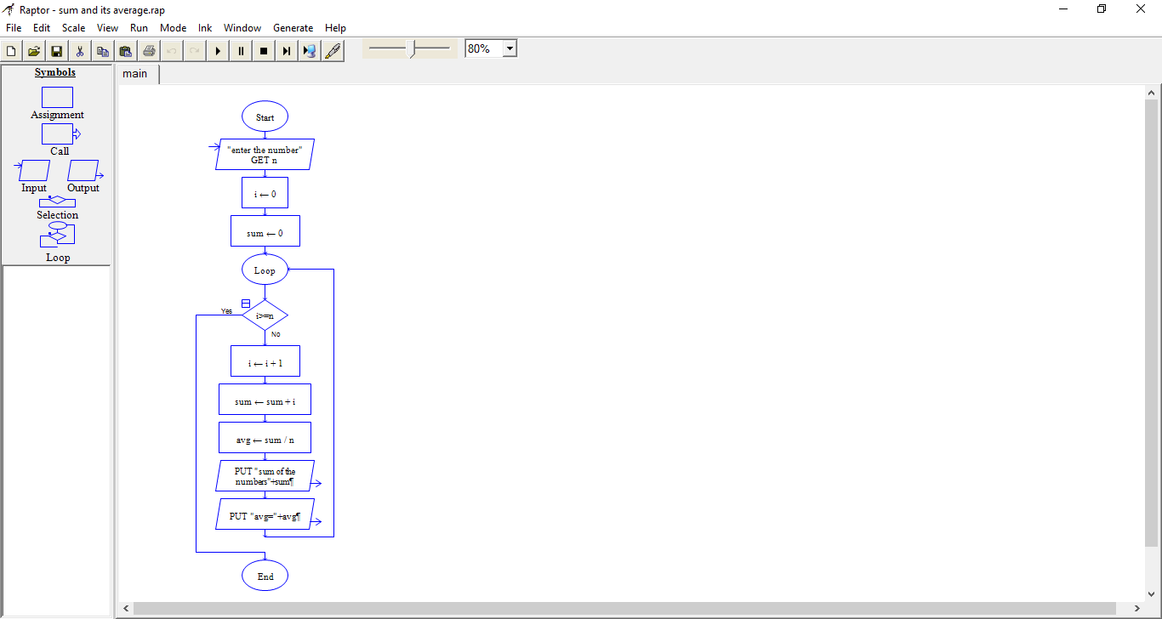

1. Printing digits of an integer number ?

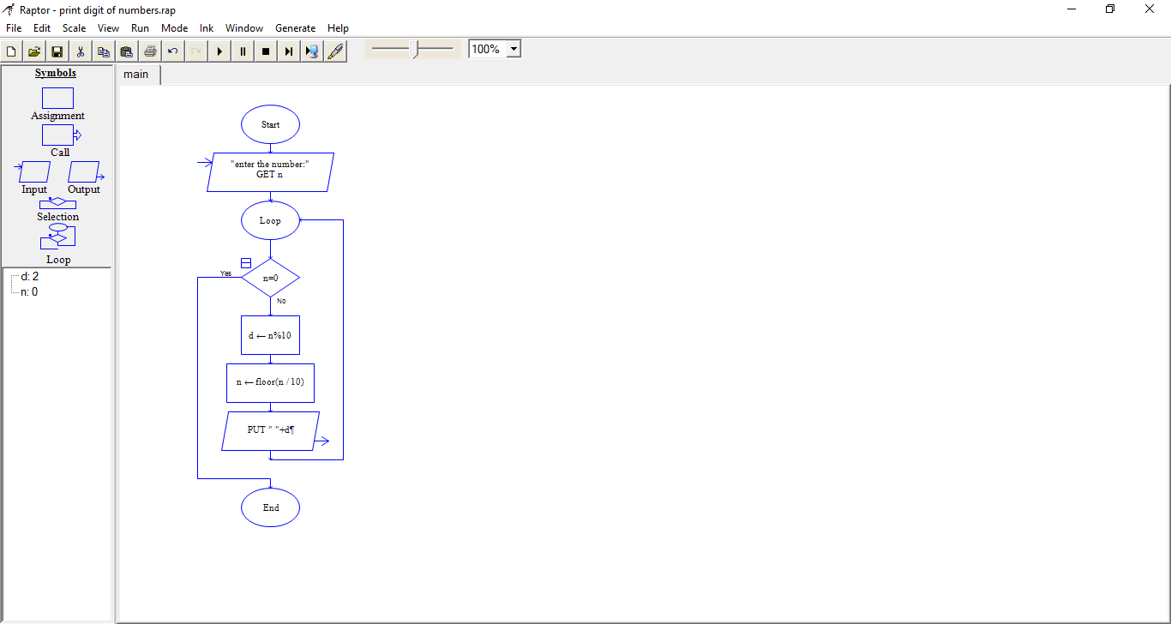

1. 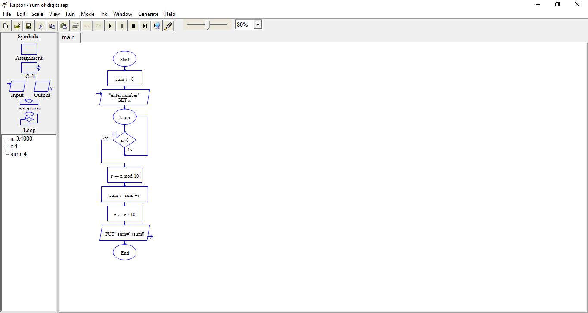Summing up the digits of an integer numbers ?
2. Reversing the digits of the integer numbers ?

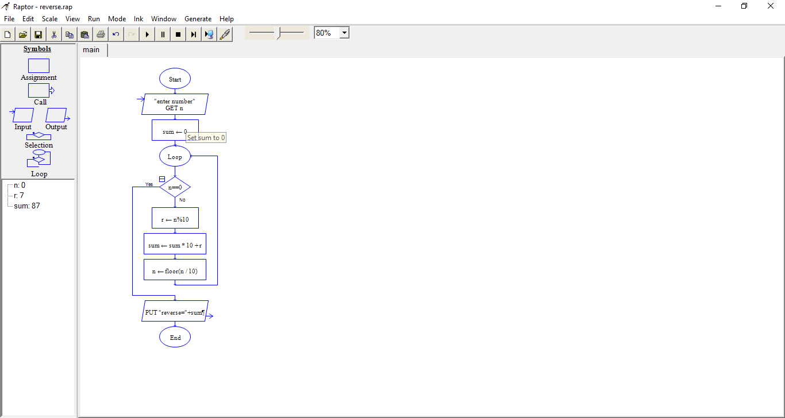

1. Finding the given integer is positive or negative ?
2. 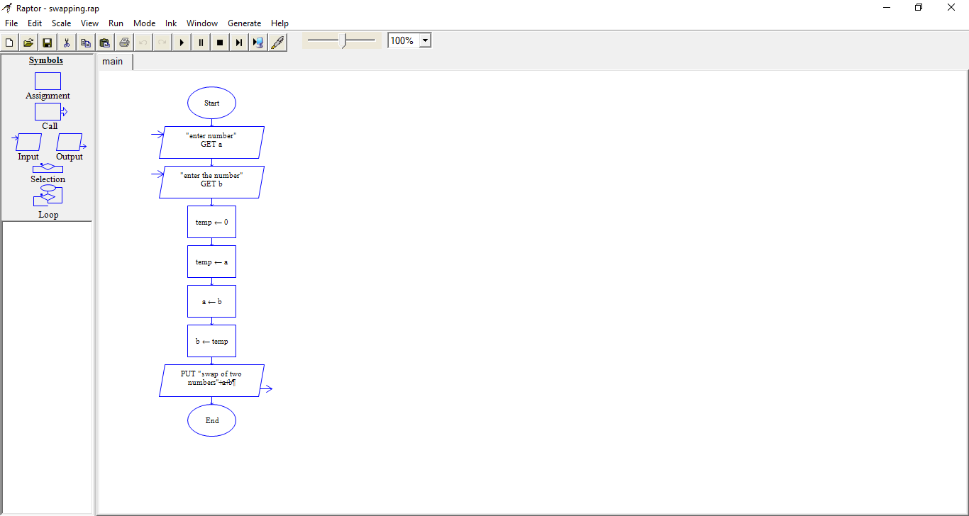Swapping two numbers with a temporary variable?